A394-Asia-China-Qadrilateral Notched Disc-Chariot Horses and Tack-Jade-Yinxu site area-Shang-1800 BCE

**Case no.:**

**Accession Number:**

**Formal Label:**

**Display Description:**

The notched disc began in northeastern China in the Hongshan culture ca 5000 BCE. The initial design of the notched disk incorporated three notches but by the Shang Period the number of notches w expanded to four since four horses were necessary to pull the heavy early Chinese war chariot. Each notch was indicated by engraved and sculpted horseheads, complete with bridals, cheek-and bit-pieces.

in Sredny Stog into two distinct phases. Phase II (ca. 5000–3500 calBCE) has perhaps the earliest evidence of horse domestication with finds suggestive of cheek-pieces (psalia), corded ware pottery which may have originated there, and stone battle-axes of the type later associated with expanding Indo-European cultures to the West. In the Ukraine horses were seasonally rounded-up, both feral for meat and domesticated for riding (noted by 3o bit-wear), along with domesticated animals (cattle and sheep) to set out on migratory journeys east to Kazakhstan between 5000-4500 calBCE. At temporary camp sites horses, cattle and sheep were selectively sacrificed in funeral rites and were depicted in mobile and rock art on their eastward journey. Then, from 3500 to 3000 cal BCE large settlements appeared on the Kazakh steppes of the Botai Culture. They too, were dependent on their horses, where 80 percent of animal bone deposits were of *Equus ferus caballus,* indicative of a horse-hunting economy both feral for meat and domesticated (noted by 3o bit-wear) for riding.

When *Equus ferus caballus* reached northeastern China in the late Shang period Yinxu site (殷墟)m where the earlier tradition of the notched disc encountered a lavish ritual assemblage of ancestral equine worship. The ideational aspect of the trilateral disc (which may have had an astronomical meaning) was now expanded to a quadrilateral equine setting, since there were four horses necessary to pull the heavy early Chinese war chariot.

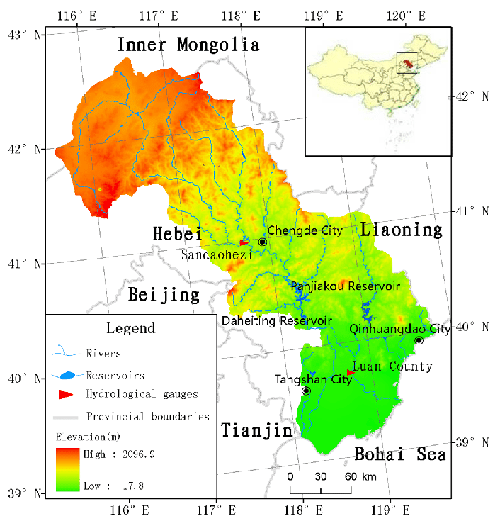

The Laiohe Valley after Yan, D & Wang, Gang & Wang, Hong & L. Qin, T. (2012). Assessing ecological land use and water demand of river systems: A case study in Luanhe River, North China. Hydrology and Earth System Sciences. 16. 2469-2483. 10.5194/hess-16-2469-2012.

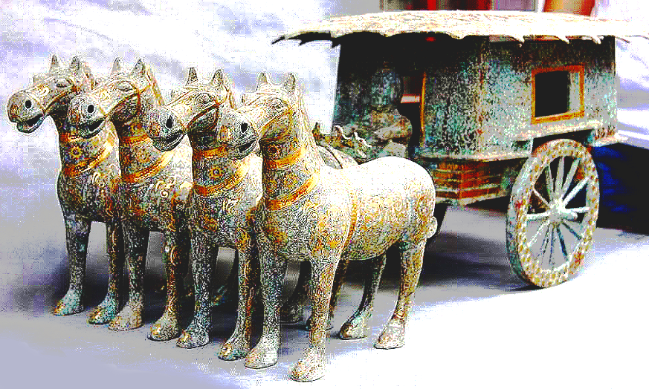

Model of a four-horse (two team) Chinese war chariot after

 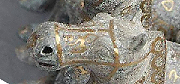

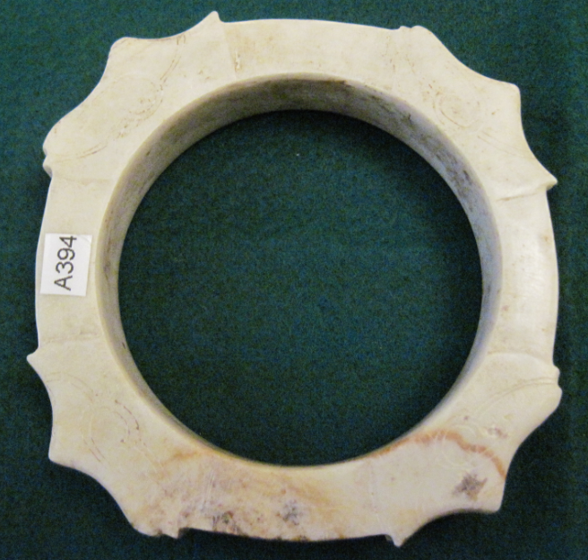

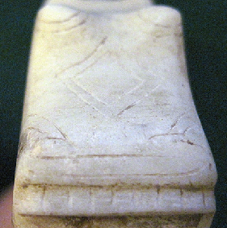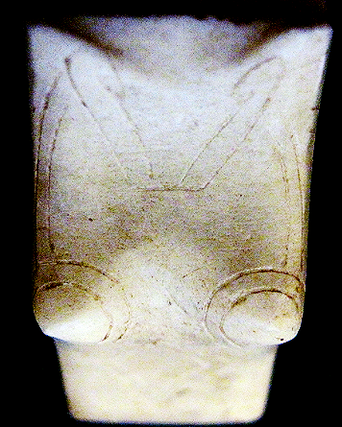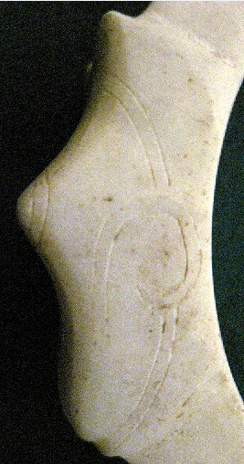

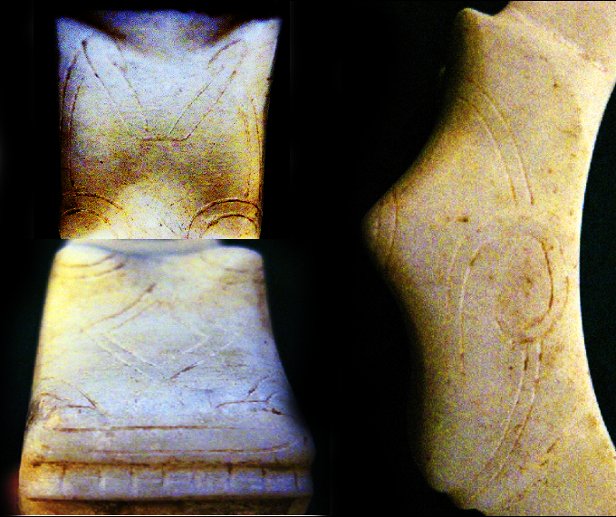

Quadrilateral disc from area of Yinzu site.

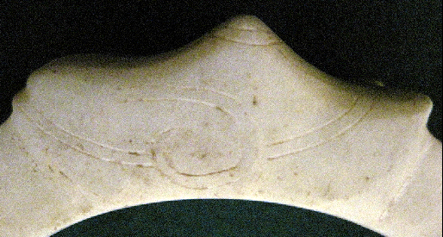

Excavations uncovered the development of chariotry, burial types and horse-bit and cheek-piece bronze metallurgy. Around 50 horse-and-chariot pits have been excavated at Yinxu (at Xiaotun NE 小屯東北地, Xibeigang 西北岡, Dasikongcun 大司空村, Xiaomintun 孝民屯, Baijiafen 白家墳, Guojiazhuang 郭家荘, Liujiazhuang N 劉家荘北地, Meiyuanzhuang SE 梅園荘東南) Xiaotun M20 was excavated in 1936 by Academia Sinica and was the first site where horses and chariots were placed in one pit, in association with organized relics such as human remains, horse remains and chariot artifacts and was considered as “an independent unit, more distinct, more regular and more important than those at Xibeigang” (Wu 2006: 13). These Shang equestrian mortuary practices led to the institutionalization of ritual equine reform of mid-late Western Zhou chariot and horse sacrifices and burial rites (Shaughnessy 1999, Falkenhausen 2006, Wu 2009). Therefore, Yinzu became an historical model that was followed in succeeding centuries.

**LC Classification:**

**Date or Time Horizon:**

**Geographical Area:**

**Map:**

**GPS coordinates:**

**Cultural Affiliation:**

**Media:**

**Dimensions:**

**Weight:**

**Condition:**

**Provenance:**

**Discussion:**

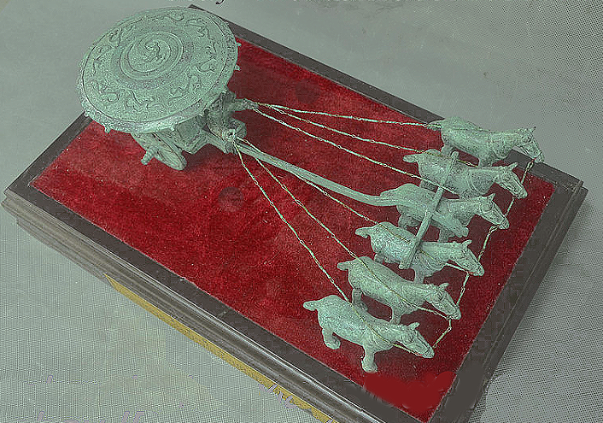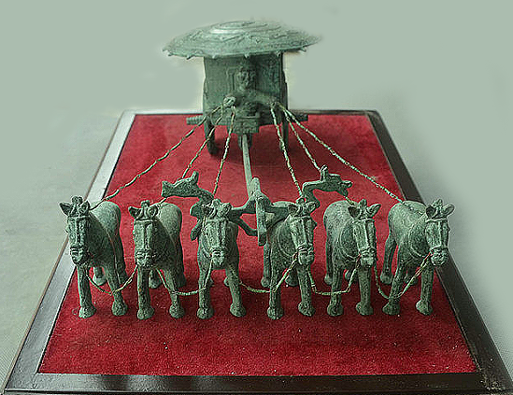

Models of a Shang six horse (three team) war chariot.

**References:**

Allan, Sarah. “Erlitou and the Formation of Chinese Civilization: Toward a New Paradigm”. The Journal of Asian Studies 66: 2, 2007, 461-496.

Anthony, David W. The Horse, the Wheel, and Language: How Bronze-Age Riders from the Eurasian Steppes Shaped the Modern World. Princeton: Princeton University Press, 2007.

Anthony, David W.; Brown, Dorcas R.; George, Christian. "Early horseback riding and warfare: the importance of the magpie around the neck". In Olsen, Sandra L.; Grant, Susan; Choyke, Alice; Bartosiewicz, Laszlo. Horses and Humans: The Evolution of the Equine-Human Relationship. British Archaeological Reports International Series. 1560. Oxford: Archaeopress, 2006, 137-156.

Anthony, David W.; Telegin, Dimitri; Brown, Dorcas. "The origin of horseback riding". Scientific American 265: 6, 1991, 94-100.

Cai, Dawei, Zhuowei Tang, Lu Han, Camilla F. Speller, Dongya Y. Yang, Xiaolin Ma, Jian’en Cao, Hong Zhu, and Hui Zhou. “Ancient DNA Provides New Insights into the Origin of the Chinese Domestic Horse.” Journal of Archaeological Science 36, no. 3 (March 2009): 835-842.

Chinese Academy of Social Sciences, Institute of Archaeology ed. Yinxu Huayuanzhuang Dongdi jiagu 殷墟花園莊東地甲骨. Kunming: Yunnan Renmin Chubanshe, 2003, 6 vols.

Chen Mengjia 陳夢家. Yinxu buci zongshu 殷虛卜辭綜述. Beijing: Zhonghua Book Company, 1988.

Dewall, Magdalene von. Pferd and Wagen im frühen China. Saarbrücken: 224 Saarbrücker Beitrage zur Altertumskunde, 1964.

Didier, John C. “In and Outside the Square: The Sky and the Power of Belief in Ancient China and the World, c. 4500 BC - AD 200. Vol. 1: The Ancient Eurasian World and the Celestial Pivot”. Sino-Platonic Papers 192, September 20

Didier and Levine

Falkenhausen 2006 Falkenhausen, Lothar von. Chinese Society in the Age of Confucius (1000-250 BC): the Archaeological Evidence. Los Angeles : Cotsen Institute of Archaeology Press, 2006.

Kelekna, Pita. The horse in human history. New York: Cambridge University Press, 2009.

Shaughnessy 1999, , Shaughnessy, E. “Historical perspectives on the introduction of the chariot into China”. Harvard Journal of Asiatic Studies 48, 1988, 189-239.

Shaughnessy, E. Sources of Western Zhouhistory: Inscribed bronze vessels. Berkeley and Los Angeles: University of California Press, 1991.

Shaughnessy, E. “Western Zhou History”, in Michael Loewe and Edward L. Shaughnessy eds., The Cambridge History of Ancient China: from the Origins of Civilization to 221 BC. Cambridge: Cambridge University Press, 1999, 292-351.

Shelach, Gideon. Leadership Strategies, Economic Activity, and Interregional Interaction: Social Complexity in Northeast China. New York, Kluwer Academic /Plenum Press, 1999.

Shelach, Gideon. “Early pastoral societies of Northeast China: Local change and interregional interaction during c. 1100 to 600 BC”, in R. Amitai and M. Biran eds., Mongols, Turks and others: Eurasian nomads and the outside world. Leiden: Brill, 15-58.

Shelach, Gideon. Prehistoric societies on the northern frontiers of China: Archaeological perspectives on identity formation and economic change during the first millennium BCE. London; Oakville, CT: Equinox Publishing Ltd., 2009.

Shelach, Gideon and Yuri Pines. “Power, identity and ideology: Reflections on the formation of the State of Qin (770-221 BCE)”, in An Archaeology of Asia, ed. M. T. Stark. Oxford: Blackwell, 202-230.

Wan, Xiang. 2013. The Horse in Pre-Imperial China. U. Penn. Ph. D. diss.

Wu 2009 Wu Xiaoyun. Shangzhou shiqi chema maizang yanjiu 商周時期車馬埋葬研究. Beijing: Kexue Chubanshe, 2009.

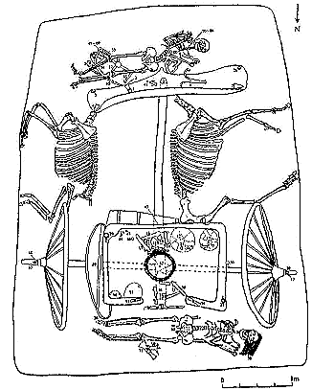

Pit M41 at Qianzhangda site, Shandong Province (CASSIA 2005: 128) showing the typical two horse chariot with two sacrificed charioteers.

References

Anthony

Didier and Levin